About the Java Technology
Java technology is both a programming language and a platform from Oracle Corporation.
Java 8 is a major update that was launched on March 18, 2014.

The Java Programming Language
The Java programming language is a high-level language that has following features:
- Simple  - Object oriented  - Distributed  - Multithreaded  - Dynamic | - Platform independent  - Portable  - High performance  - Robust  - Secure

In the Java programming language, all source code is first written in plain text files ending with the .java extension. Those source files are then compiled into .class files by the javac compiler. A .class file does not contain code that is native to your processor; it instead contains bytecodes — the machine language of the Java Virtual Machine¹ (Java VM). The java launcher tool (JRE) then runs your application with an instance of the Java Virtual Machine.
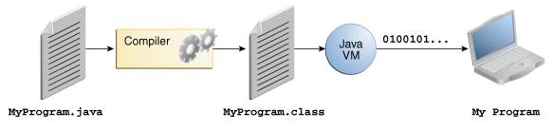
An overview of the software development process.
Because the Java VM is available on many different operating systems, the same .class files are capable of running on Microsoft Windows, the Solaris™ Operating System (Solaris OS), Linux, or Mac OS. Most of the virtual machines, such as the Java SE HotSpot perform additional steps at runtime to give your application a performance boost. This include various tasks such as finding performance bottlenecks and recompiling (to native code) frequently used sections of code.
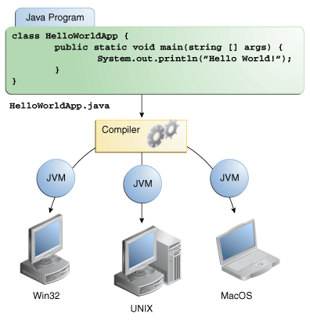
Through the Java VM, the same application is capable of running on multiple platforms.

The Java Platform
A platform is the hardware or software environment in which a program runs. Some of the most popular platforms are Microsoft Windows, Linux, Solaris OS, and Mac OS. Most platforms can be described as a combination of the operating system and underlying hardware. The Java platform differs from most other platforms in that it's a software-only platform that runs on top of other hardware-based platforms.
The Java platform has two components:
- The Java Virtual Machine
- The Java Application Programming Interface (API)
Java Virtual Machine (JVM) is the base for the Java platform and is ported onto various hardware-based platforms.
The API is a large collection of ready-made software components that provide many useful capabilities. It is grouped into libraries of related classes and interfaces; these libraries are known as packages. API mainly consists of jar and dll files.
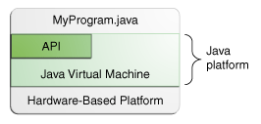
The API and Java Virtual Machine insulate the program from the underlying hardware.
As a platform-independent environment, the Java platform can be a bit slower than native code. However, advances in compiler and virtual machine technologies are bringing performance close to that of native code without threatening portability.

